This Perceptron was made in KNIME after several failed attempts at using perceptron libraries for python.

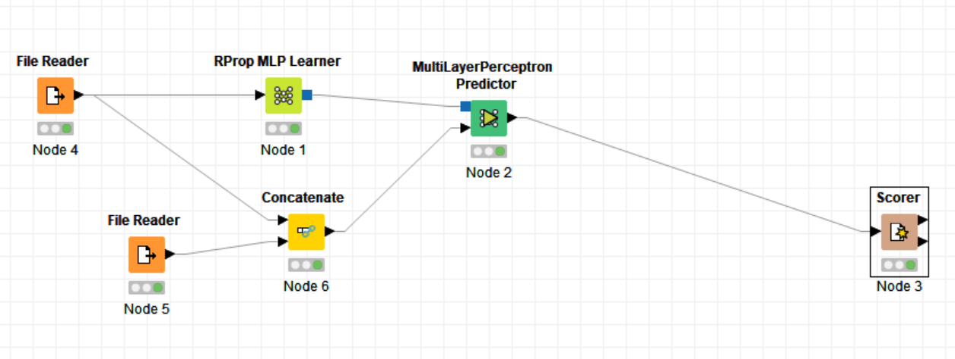

It ended up having a hidden layer, but even the libraries I tried for had no options to have zero hidden layers, quite frustrating really. It has the same number of training iterations as the one I made. Here is the confusion matrix.

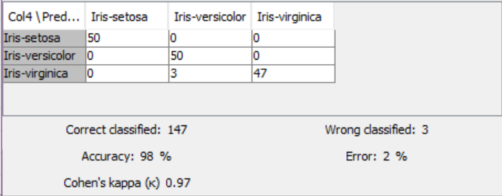

Very accurate. Compared to my model, I guess that’s because of the hidden layer, as well as it doesn’t use simple feedback learning.

Recall and Precision are in the text file.